Aromatic polyisocyanates based on Toluene Diisocyanate (TDI)

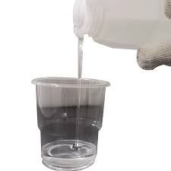

Description
Aromatic polyisocyanates based on toluene diisocyanate (TDI) are widely used as hardeners in two-component polyurethane (2K PU) coatings and adhesives, particularly for applications like wood and furniture finishes, industrial coatings, and flexible packaging. These polyisocyanates are typically formed by reacting TDI with other polyols or polyamines to create a molecule with multiple isocyanate groups, allowing for crosslinking with other components in the formulation.

Product family:
Isocyanate Monomers

Chemical family:
Aromatic Isocyanate
polyisocyanates based on toluene diisocyanate (TDI)

Product Type:
Crosslinker of Polyurethane Resin

Benefits
- Fast drying
- Hardness
- Compatibility with polyol

Applications
Aromatic polyisocyanates based on toluene diisocyanate (TDI) are used in the formulation of fast drying two-component clear and pigmented polyurethane coatings for wood, metal, textiles, paper, plastics, rubber and mineral substrates.

Technical Data Sheet

