Blocked Aromatic Polyisocyanate Based On Toluene Diisocyanate(TDI)

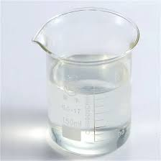

Description
NewChem-2099 is an aromatic polyisocyanate based on toluene diisocyanate. It can be mixed with the aliphatic polyisocyanates, polyester polyols, aromatic polyisocyanates and polyacrylates with various hydroxyl-bearing. It is used to formulate one-component polyurethane coatings and adhesives. A blocked isocyanate crosslinker is a molecule where an isocyanate group, which is highly reactive, has been temporarily "blocked" by a blocking agent. This blocking agent makes the isocyanate stable and non-reactive at room temperature, but it can be released upon heating, allowing the isocyanate to react and crosslink with other molecules.

Product family:
Isocyanate Monomers

Chemical family:
Blocked Isocyanate
Aromatic Isocyanate
Toluene Diisocyanate

Product Type:
Crosslinker of Polyurethane Resin

Benefits
Crosslinking with blocked isocyanates can lead to improved durability, adhesion, chemical resistance, and other desirable properties in the final product.
- Good hardness
- Good gloss
- Good flexibility and toughness

Applications
Blocked aromatic polyisocyanate based on TDI is used in formulation of stoving coatings for coil and metal cans industry. It is used as a hardener of polyester and acrylic resins with excellent corrosion resistance. Blocked isocyanates are used in both solvent-based and water-based coatings to improve their durability, adhesion, and chemical resistance.

Technical Data Sheet

