Anionic Polyelectrolyte Flocculants
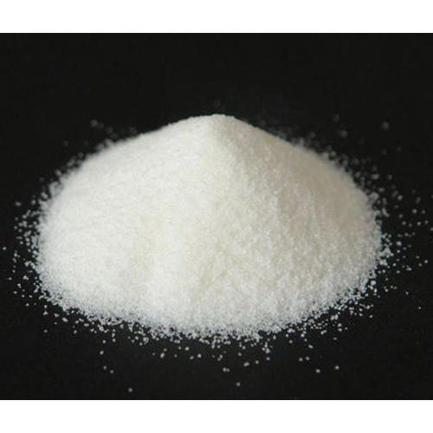

Description
NewChem-A10 is an anionic polyacrylamide. Anionic polyelectrolyte flocculants are water-soluble polymers with negatively charged units, used to clump together suspended particles in liquids, promoting their separation and settling. They are widely used in various applications, including wastewater treatment, paper manufacturing, and mining.

Product family:
Anionic polyelectrolyte

Chemical family:
Anionic polyacrylamide
Anionic polyelectrolyte flocculants

Product Type:
Flocculants

Benefits
- Effective flocculant and dispersant.
- Medium-High degree of charge (anionicity).
- Medium molecular weight for specific applications.
- Performs well in a pH range of 6-9.
- Easily soluble in water.

Applications
Anionic polyelectrolytes act as flocculants by binding to suspended particles in a liquid, neutralizing their surface charges, and bridging them together. This causes the particles to clump into larger, heavier flocs that settle out of the solution more easily.
- Wastewater Treatment:
Anionic polyelectrolytes are commonly used to remove suspended solids, turbidity, and other pollutants from wastewater in municipal and industrial treatment plants.
- Paper manufacturing:
They can improve paper quality by aiding in retention of fibers and other additives, and also help with dewatering and clarification of wastewater in the paper mill.
- Mining:
They are used in mining operations for dewatering of tailings and clarifying wastewater from mineral processing.
- Food Processing:
They can be used to clarify sugar cane juice and other food processing byproducts.
- Oil extraction:
Anionic polyelectrolytes can be used for profile control and water plugging in oil fields.
- Other Industries:
They also find applications in the petrochemical, metallurgical and dyeing industries.

Technical Data Sheet

