Cationic Polyelectrolyte Flocculants
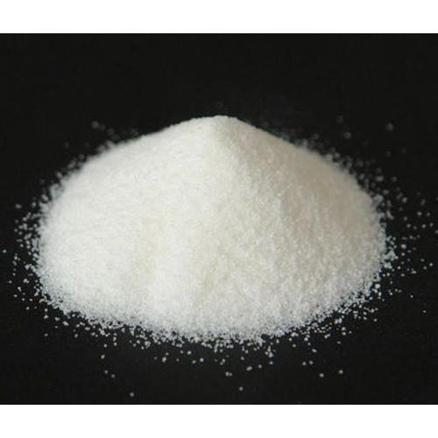

Description
NewChem-C10 is a cationic polyacrylamide. Cationic polyelectrolyte flocculants are water-soluble polymers with positively charged repeating units, primarily used in wastewater treatment and other industrial applications to remove suspended solids. They work by neutralizing the negative charges of particles in wastewater, causing them to clump together and settle out, facilitating separation and purification.

Product family:
Cationic polyelectrolyte

Chemical family:
Cationic polyacrylamide
Cationic polyelectrolyte flocculants

Product Type:
Flocculants

Benefits
- Effective flocculant for solid-liquid separation.
- Medium-High cationic charge density.
- Medium molecular weight for specific applications.
- Performs well in a pH range of 6-8.
- Easily soluble in water.

Applications
Cationic polyelectrolytes have a positive charge, meaning they have an abundance of positive ions or groups like quaternary ammonium or amine groups. These polymers are designed to promote flocculation, the process of aggregating suspended particles into larger, settleable clumps (flocs).
- Wastewater Treatment:
Cationic polyelectrolytes are widely used to dewater sewage sludge, remove suspended solids from industrial wastewater, and improve water clarity.
- Paper manufacturing:
They enhance the strength and drainage of paper during the manufacturing process.
- Mining:
They are used in mineral processing to separate valuable ores from waste materials and in sludge dewatering.
- Other Industries:
They find use in various other applications like sugar processing, textile dyeing, and oil field operations.

Technical Data Sheet

